CO – IMPLEMENTATION EXAM

[Conducted By Mitali Mam]

[U19CS012]

Problem Statement: To Modify Assignment 7 Circuit [(X+Y)/2] to [(X+Y+Z)/3].

Circuit Diagram:

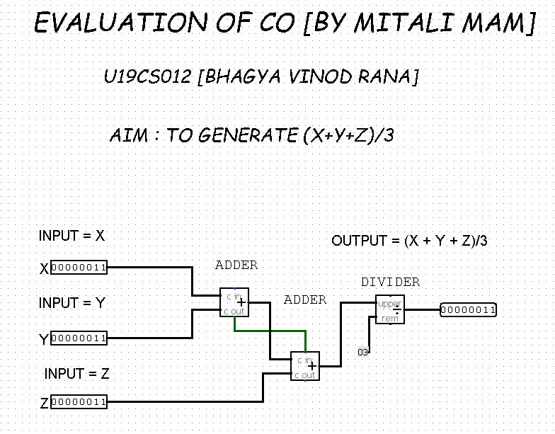

Test Cases:

A.) x = 2, y = 1, z = 3 -> (x+y+z)/3 = 6/3 = 2 = [0000 0010]

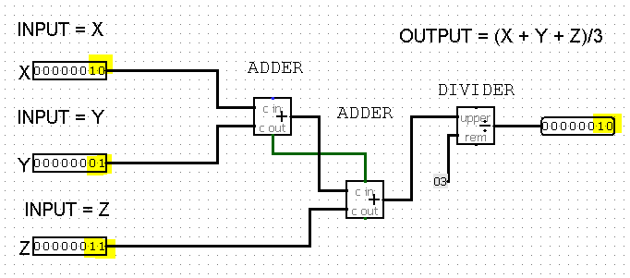

B.) x = 7, y = 10, z = 5 -> (x+y+z)/3 = floor(22/3) = 7 = [0000 0111]

